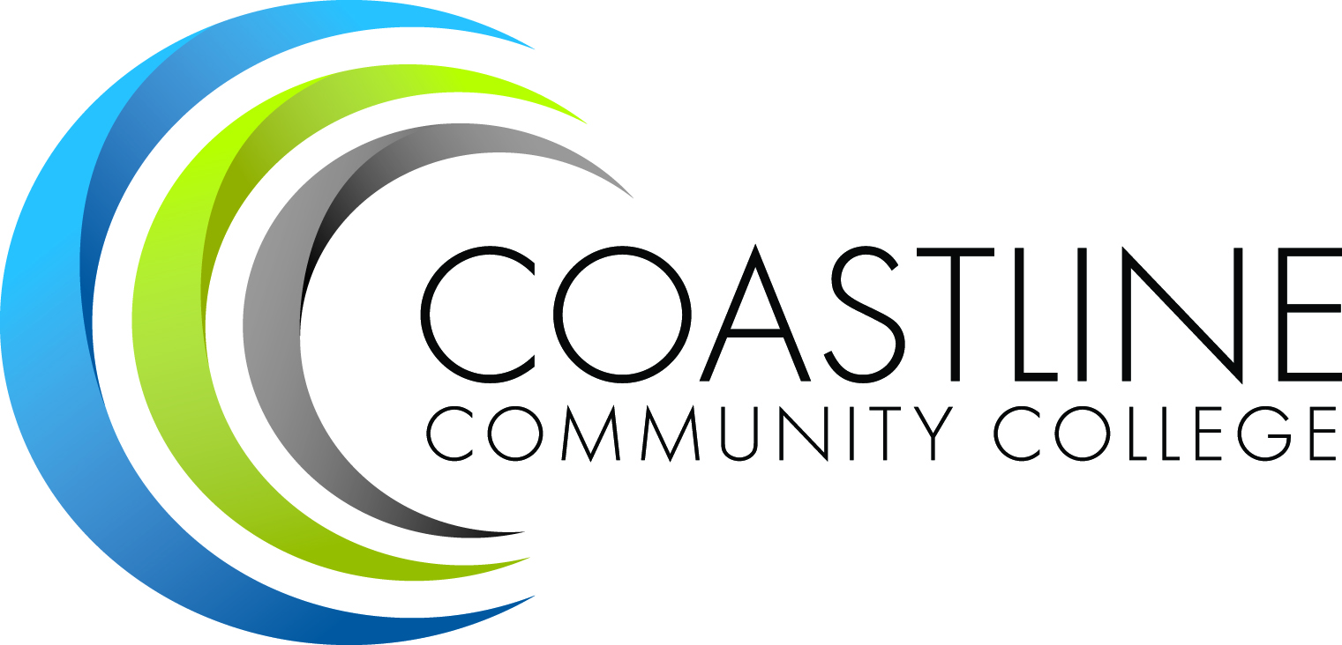
MEETING AGENDA
Coastline Community College

DATE/TIME: February 18, 2015 / 1:30 p.m. to 3:30 p.m.

LOCATION: Fourth Floor Conference Room

MEETING: Planning, Institutional Effectiveness, and Accreditation Committee (PIEAC)

 | Member |  | Member
 | Lori Adrian |  | Rick Lockwood
 | Darian Aistrich |  | Ross Miyashiro
 | Gayle Berggren |  | Christine Nguyen
 | Chris Blackmore |  | Michelle Priest
 | Scott Davis |  | Vince Rodriguez
 | Kevin Erdkamp |  | Helen Rothgeb
 | Marilyn Fry |  | Celeste Ryan
 | Joycelyn Groot |  | Wendy Sacket
 | Pedro Gutierrez |  | Jorge Sanchez
 | Ann Holliday |  | Cheryl Stewart
 | Nhadira Johnson |  | Dave Thompson
 | Nancy Jones |  | Helen Ward
 | Linda Kuntzman |  | Lois Wilkerson
 | Lisa Lee |  | Susan Winterbourne
 | Heidi Lockhart |  | Aeron Zentner

Mandate: To provide oversight and leadership in support of institutional effectiveness and, through ongoing intentional College-wide evaluation, dialogue, planning, coordination, and use of systematic data to ensure student learning, ensure that the College fulfills its mission and meets or exceeds institutional accreditation standards. PIEAC makes recommendations to the President through College Council, and through appropriate bodies as necessary, and all bodies provide reports to the PIEAC.

- Meeting Convened |  |  | Co-Chairs
- Introduction of Guests |  |  | Co-Chairs
- Approval/Addition of Agenda Items |  |  | Committee
- Approval of Draft Minutes |  |  | Committee
Discussion Items:
One time Funding Requests |  | Christine Nguyen
2013/14 Expenditure Report |  | Christine Nguyen
2014/15 Mid-year Expenditure Report |  | Christine Nguyen
Update on Master Plan |  | Vince Rodriguez/ Aeron Zentner
Priority Allocation Rubric |  | Vince Rodriguez
Instructional Planning Guide |  | Vince Rodriguez
Accreditation Standard Structure |  | Lori Adrian
SLO Taskforce Update |  | Gayle Berggren
Scorecard KPI Discussion |  | Aeron Zentner
Mission Statement |  | Vince Rodriguez
Reports and Updates:
President’s Report |  | Lori Adrian
Wing Updates |  | Vince Rodriguez Christine Nguyen  Ross Miyashiro
Program Review |  | Aeron Zentner
Budget Committee |  | Rick Lockwood
College Council |  | ? Please advise
Other Committees |  | Committee
Meeting Recap |  | Ann Holliday
ADJOURNMENT |  | 3:30 P.M.
Next Meeting:
** March 4, 2015 / 1:30 p.m. to 3:30 p.m. / Fourth Floor Conference Room
Vision Statement: Creating opportunities for Student Success.

Mission Statement: Coastline Community College promotes academic excellence and student success for today's global students through accessible, flexible, innovative education that leads to the attainment of associate degrees, transfers, certificates, basic skills readiness for college, and career and technical education.

